**Lab: Linear-Data-Structures**

This document defines the lab for ["Data Structures – Fundamentals (Java)" course @ Software University](https://softuni.bg/trainings/4275/data-structures-fundamentals-with-java-september-2023). Please submit your solutions (source code) of all below-described problems in [Judge](https://judge.softuni.bg/Contests/2034/01-Linear-Data-Structures-Lab).

Write Java code for solving the tasks on the following pages. Code should compile under the Java 8 and above standards, you can write and locally test your solution with the Java 13 standard, however, **Judge will run the submission with Java 10 JRE**. Avoid submissions with **features included after Java 10** release doing **otherwise** will result in **compile time error**.

Any code files that are part of the task are provided as **Skeleton**. In the beginning import the project skeleton, do not change any of the interfaces or classes provided. You are free to add additional logic in form of methods in both interfaces and implementations you are not allowed to delete or remove any of the code provided. Do not change the names of the files as they are part of the tests logic. **Do not change the packages** or move any of the files provided inside the skeleton if you have to add a new file add it in the same package of usage.

Some **tests may be provided** within the skeleton – use those for local **testing and debugging**, however, there **is no guarantee that there are no hidden tests added inside Judge**.

Please follow the exact instructions on uploading the solutions for each task. Submit as **.zip archive** the files contained inside the **"...\src\main\java"** folder this should work for all tasks regardless of current DS implementation.

For the solution to compile the tests **successfully** the project **must** have a **single** **Main.java** file containing single **public static void main(String[] args)** method even an empty one within the **Main class**.

Some of the problems will have simple **Benchmark** **tests** inside the skeleton. You can try to run those with **different** **values** and **different** **implementations** to **observe** behavior. However, **keep** in mind that the result comes **only as numbers** and this data may be **misleading** in some situations. Also, the tests are not started from the command prompt which may **influence** the **accuracy** of the results. Those tests are only added as an **example** of **different** **data** **structures'** **performance** on their **common** operations.

The Benchmark tool we are using is **JMH** (Java Microbenchmark Harness) and that is a Java harness for building, running, and analyzing, **nano/micro/milli/macro** benchmarks written in Java and other languages targeting the JVM.

**Additional** **information** can be found here: [JMH](https://openjdk.java.net/projects/code-tools/jmh/) and also there are other examples over the **internet**.

**Important:** when importing the skeleton **select** **import** **project** and then **select** **from** the **maven** **module**, this way any following **dependencies** will be **automatically** **resolved**. The project has **NO** **default** **version** of **JDK so after the import you may (depending on some configurations) need to specify the SDK, you can download** **JDK 13** from [**HERE**](https://jdk.java.net/13/)**.**

## ArrayList

Your task is to implement the **ADS** **List<E>** inside the **ArrayList<E>** class provided. You can see that this class implements the **List<E>** interface you have to implement all the methods to solve the problem, however, you are free to add more methods with any access modifier you want.

### ****Boolean add (****E element) – adds an element at the end of the sequence and returns true if successful (always returns true). This method should in addition increase the size of the structure and ensure that there is enough space for the addition to work. If needed you will have to resize the array.

### Boolean add (int index, E element) – the only difference from the above one is that now we have a specified index at which to add (insert) an element. This time you have to validate the index then add the element and shift the remaining elements if any from the index + 1 to the right (from the index + 1 to the last index + 1).

### E get (int index) – returns the element at the given index and does not remove it from the collection. If the index is invalid throw IndexOutOfBoundsException with a proper message of your choice (the message itself is not subjected to testing).

### E set (int index, E element) – sets the element at given index and returns the previously stored at that index element, again you should validate the index and throw IndexOutOfBoundsException if the validation fails.

### E remove (int index) – removes the element at the specified index and returns it – again the same validation, here you should already have some way to reuse the index validation.

### Int size () – returns the number of elements.

### Int indexOf (E element) – returns the index of an element if the element is not present in the structure then returns -1 as an invalid array index.

### Boolean contains (E element) – returns true or false if the element is present inside the structure.

### Boolean isEmpty () – returns if there are elements stored or not.

### Solution:

##### Boolean add (E element):

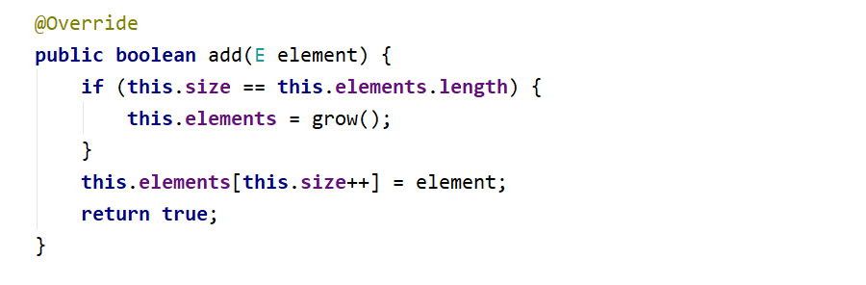

##### The – grow () helper method:

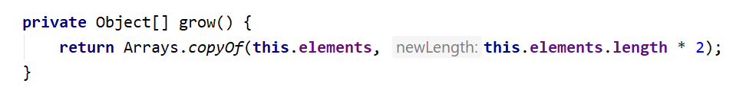

##### Boolean add (int index, E element):

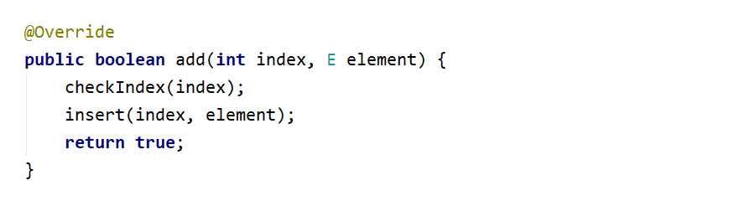

##### The insert (int index, E element) method:

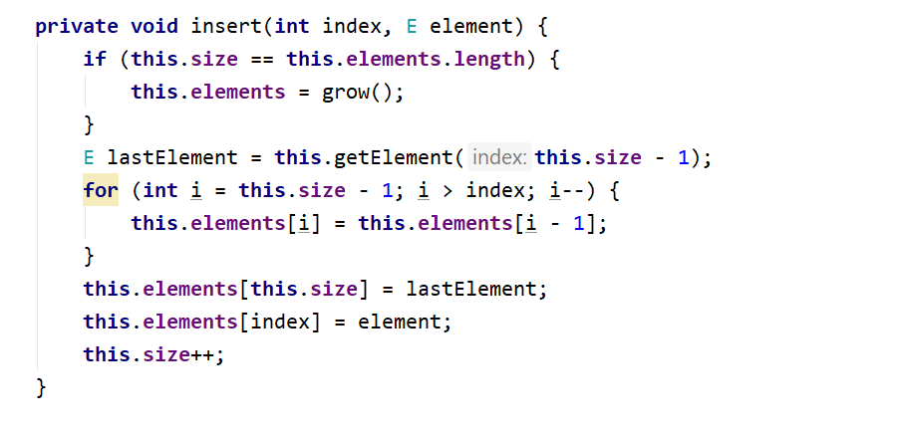

##### E get (int index):

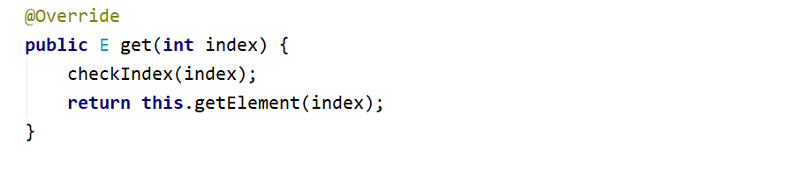

##### E set (int index, E element):

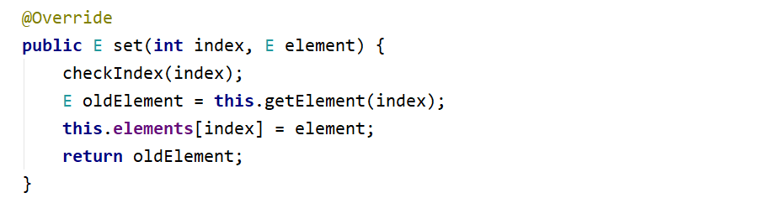

##### E remove (int index):

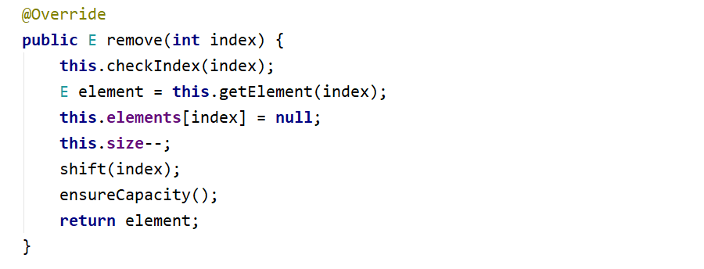

##### Take a look at those additional helper methods, you can reuse them whenever needed: First, ensure the capacity of the array if we have less than one-third of the elements we can shrink the array.

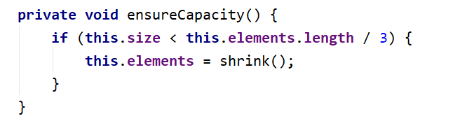

##### The shrinking method looks a lot like grow with one major difference – we reduce the space:

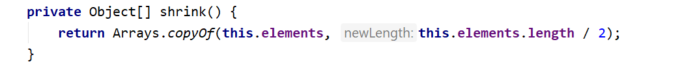

##### And last but not least the check index method, feel free to modify the message.

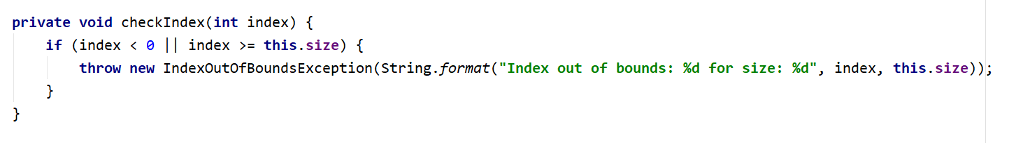

##### Iterator<E>

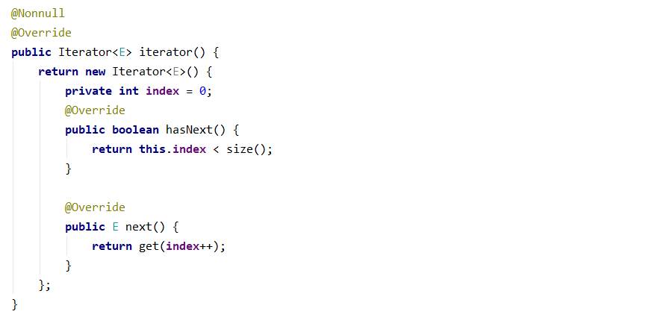

All of the **other** **methods** are **easy** and **straightforward** to be **implemented** so you won't need any help. If it doesn't work the first time **simply try a different approach**.

## Stack

### Your task is to implement the ADS AbstractStack<E> inside the Stack<E> class provided. You have to implement all the methods to solve the problem, however, you are free to add more methods with any access modifier you want.

### Push (E element) – adds an element at the top of the stack and increases the size.

### E pop () – removes an element at the current top of the stack and returns it if there is an element if the stack is empty throw IllegalStateException with an appropriate message.

### E peek () – return the element at the current top of the stack if the stack is empty throw IllegalStateException with an appropriate message.

### Int size () – returns the number of elements inside the stack.

### Boolean isEmpty () – returns if the stack contains any elements or not.

### Solution:

##### Push (E element)

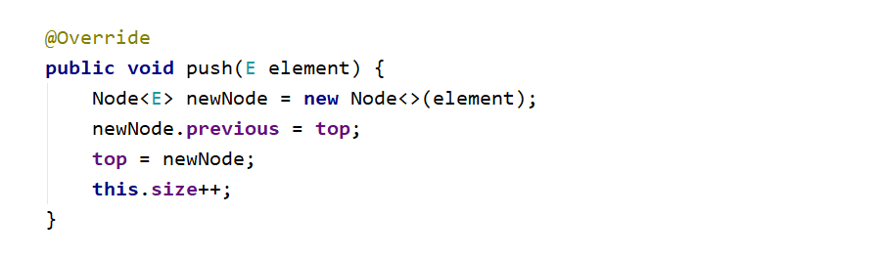

##### E pop ()

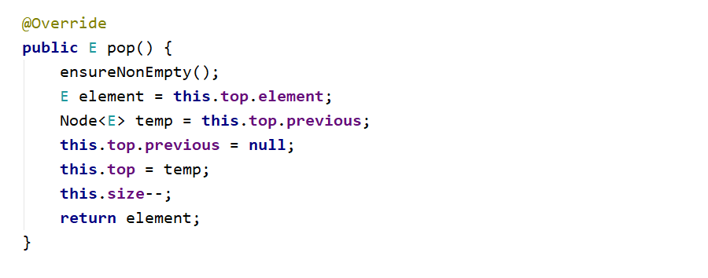

##### E peek ()

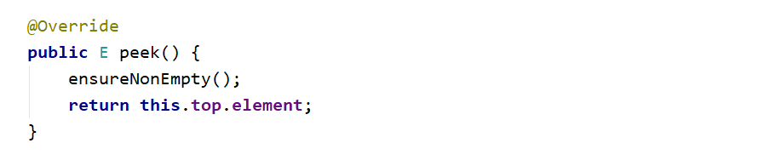

##### Iterator<E>

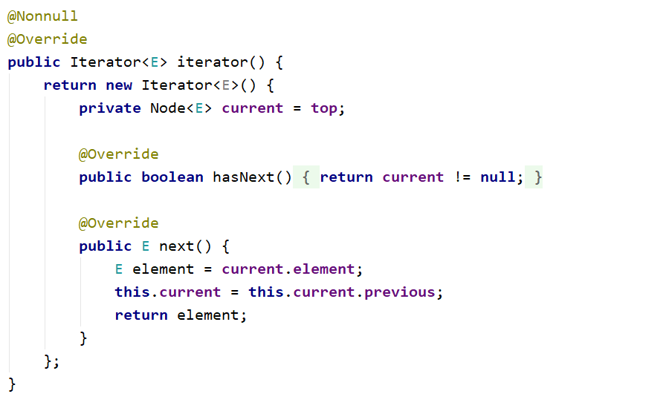

All of the **other** **methods** are **easy** and **straightforward** to be **implemented**. If it doesn't work the first time **simply try a different approach**.

## Queue

Your task is to implement the **ADS** **AbstractQueue<E>** inside the **Queue<E>** class provided. You have to implement all the methods to solve the problem, however, you are free to add more methods with any access modifier you want.

* **Offer (E element)** – **adds** an **element** at the **end** of the **queue** and increases the size.

##### E poll () – removes and returns the first element at the queue also decreases the size and performs a check if this method is called upon empty collection if so throw IllegalStateException with a message of your chose the message itself will not be tested.

##### E peek () – return the element at the current front of the queue if the collection is empty throw IllegalStateException with an appropriate message.

##### Int size () – returns the number of elements inside the stack.

##### Boolean isEmpty () – returns if the stack contains any elements or not.

### Solution:

As you can see a lot of the operations **described** **above** are a lot like those we did on the **Stack** problem so think about **how** you can **reuse** and **modify** those. Now you can see a **slightly** **different** way of adding the elements in the **stack** **implementation** we had a **pointer** to the **top** **element** here we have to **the** **first** pointer so you need to **find** the **last** **element** so you can **offer** the **new** **node**. The only specific problem here is the **poll ()** method:

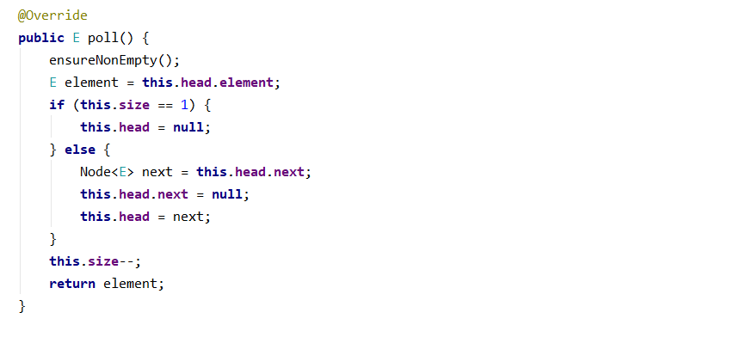

## SinglyLinkedList

Your task is to implement the ADS List<E> inside the ArrayList<E> class provided. You can see that this class implements the List<E> interface you have to implement all the methods to solve the problem, however, you are free to add more methods with any access modifier you want.

### AddFirst (E element) – adds an element in front of the collection and increases the size.

### AddLast (E element) – adds an element after the last element of the collection and increases the size.

### E removeFirst () – removes and returns the first element of the collection if it is such if no then throw IllegalStateException with the appropriate message.

### E removeLast () – removes and returns the last element of the collection if it is such if no then throw IllegalStateException with the appropriate message.

### E getFirst () – returns but does not remove the first element of the collection if it is such if no then throw IllegalStateException with the appropriate message.

### E getLast () – returns but does not remove the last element of the collection if it is such if no then throw IllegalStateException with the appropriate message.

### Int size () – returns the number of elements inside the collection.

### Boolean isEmpty () – returns if the collection contains any elements or not.

### Solution:

Here comes the **tricky** **part**, **all** of the **operations** above **are** **alike** the **previous** **ones** you have implemented combined and modified of course. But in really small and simple matters so try to solve those on your own. **Good Luck!** And **remember** if something gets **too** **complicated** or **unclear** and **does** **not** **work** you can **always start again by choosing a different approach.**

"The presence of those seeking the truth is infinitely to be preferred to the presence of those who think they've found it." ― Terry Pratchett, Monstrous Regiment